HOW TO TRHOBLEESHOOT OSS2 WORKER CLUSTER POSTGRES

Jika error demoted wait primary
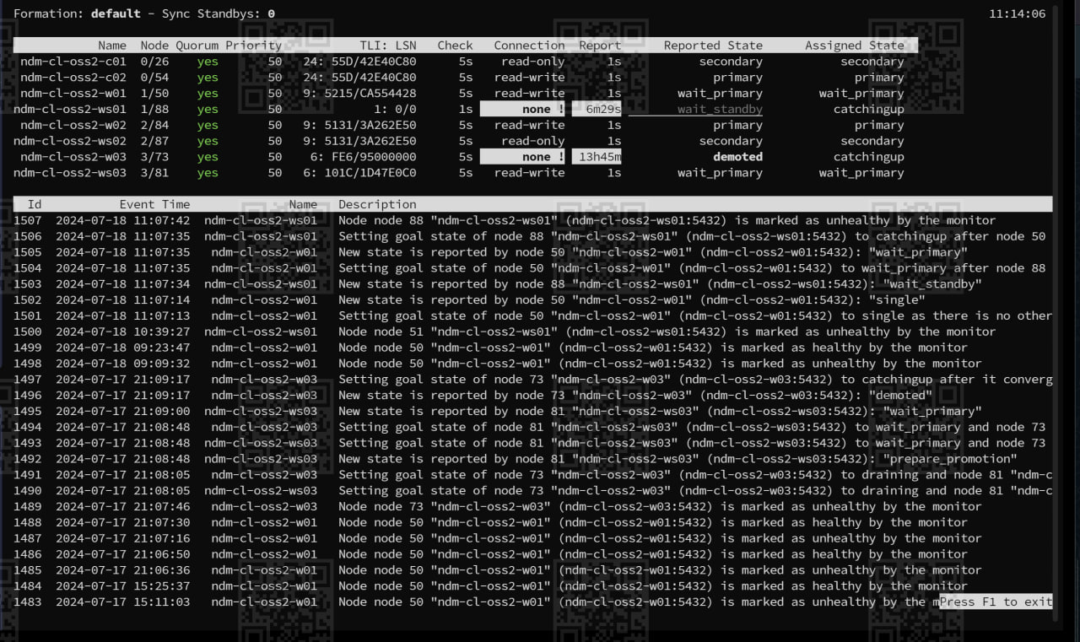

Stop service
